System Requirements Statement (SRS) –

Online PG Rental System

Created by : Priya Kotecha, Ankur Mahalle, Ashiph Sayyad, Rajashree Patil

Date :21-Aug-2021

1. Introduction 3

2. Functional Requirements 4

2.1 Tenant Module 5

2.2 Landlord/Owner Module 10

2.3 Admin Module 15

2.4 Use Case Diagram 18

THIS DOCUMENT CONTAINS 20 NUMBERED PAGES

# Introduction

This document explains the system requirements and scope for developing Online PG Rental System.

Online PG Rental System could divide the three main parts, Tenant part, Landlord/Owner part, Admin part.

This document describes the system requirement of the Account part.

# Functional Requirements

The Account part of Online PG Rental System has three modules which are divided 13 processes described as below.

|  |  |  |
| --- | --- | --- |
| **No** | **BRS requirement ID** | **Description** |
| **2.1** | **Tenant Module** | |
| **2.1.1** | **F1** | **Account Creation Process** |
| **2.1.2** | **F2** | **Login Process** |
| **2.1.3** | **F3** | **Forgot Password Process** |
| **2.1.4** | **F4** | **Change Password Process** |
| **2.1.5** | **F5** | **Update Account Process** |
| **2.1.6** | **F6** | **Search and Select Properties** |
| **2.1.7** | **F7** | **Browse details of properties** |
| **2.2** | **Landlord/Owner Module** | |
| **2.2.1** | **F11** | **Account Creation Process** |
| **2.2.2** | **F12** | **Login Process** |
| **2.2.3** | **F13** | **Forgot Password Process** |
| **2.2.4** | **F14** | **Change Password Process** |
| **2.2.5** | **F15** | **Update Account Process** |
| **2.2.6** | **F16** | **Upload Property details** |
| **2.2.7** | **F17** | **Update property details** |
| **2.2.8** | **F18** | **Delete property details** |
| **2.2.9** | **F19** | **Finalize Deal** |
| **2.3 Admin Module** | | |
| **2.3.1** | **F21** | **Login Process** |
| **2.3.2** | **F22** | **Forgot Password Process** |
| **2.3.3** | **F23** | **Change Password Process** |
| **2.3.4** | **F24** | **Update Account Process** |
| **2.3.5** | **F25** | **Report Generation** |
| **2.3.6** | **F26** | **Account Management** |

## Tenant Module

* Tenant is the user of system who wants to search for the properties on rent.
* He is also able to view the property details after registering.

### Account Creation Process

* Online PG Rental System compels to create the account before using it. So, Online PG Rental System should provide the function which makes tenant creates new account.
* When tenant creates new account, the function demands information described as below.

1. Registration

* The Registration information consists of some items described as below.

1. First Name
2. Last name
3. E-mail ID
4. Password
5. User Type
   1. All items are compulsory demanded.
   2. First Name

* The First Name has constraints described as below.

1. Capital alphabet (A-Z)(first letter should be capital)
2. Small alphabet (a-z)(remaining letter should be small)
   1. Last Name

* The Last Name has constraints described as below.

1. Capital alphabet (A-Z)(first letter should be capital)
2. Small alphabet (a-z)(remaining letter should be small)
   1. E-mail ID

* If the Email ID correspond with not case-sensitive to other which is previously registered, the Email-ID should not be registered as an account.
  1. Password
* The Password has constraints which makes the Password consists of more than or

equal 8 and less than or equal 16 characteristics including characters described as below.

1. Numeric figure (at least one)
2. Capital alphabet (A-Z)(at least one)
3. Small alphabet (a-z)(at least one)
4. Special character (#, $, %, &, etc.) (at least one)

* The Password is masked by dummy characters. The re-entering Password is demanded.
* The Password must be encrypted in Online PG Rental System.
  1. User Type

The User Type falls into two categories described as below.

1. Tenant
2. Landlord/Owner

* The User Type defines two types of users; "Tenant", "Landlord/Owner".
* In an Account Creation Process, the user can select Tenant or Landlord/Owner.
* Registration information should be entered on one screen and Login information should be entered on another screen after confirmed registration.

### Login Process

* Online PG Rental System always compels user authentication before using itself except when a new account is successfully created.
* The Login information
  1. Email-ID
  2. Password
* The user authentication demands Email-ID and Password. The Email-ID and the Password should be checked in three ways.
  1. First, The Email-ID and the Password should be existed and correct.
* If The Email-ID and the Password are not equal to what the user has registered, the user authentication cannot be provided.
  1. Second, the User Type linked to the Email-ID should be "Tenant".
* When the User Type is "Tenant",then user can be placed on “Tenant’s Dashboard”.
  1. Finally, Email-ID should be available.
* The Administrator can decide whether the Email-ID is available or suspended – Refer to the SRS of the Admin part.
* If Tenant registration is timed out, user authentication is not provided for system user.
  1. Password
* The Password has constraints which makes the Password consists of more than or equal 8 and less than or equal 16 characteristics including characters described as below.

1. Numeric figure (at least one)
2. Capital alphabet (A-Z)(at least one)
3. Small alphabet (a-z)(at least one)
4. Special character (#, $, %, &, etc.) (at least one)

* The Password is masked by dummy characters. The re-entering Password is demanded.
* The Password must be encrypted in Online PG Rental System.
  1. The Tenant account should alive for so long as the duration decided by Admin.
  2. Only when all the checks are successfully completed, Tenant can be placed on respected page.
  3. The “Tenant Dashboard” provides some of the features described as below.

1. A trigger to logout
2. A trigger to update Account
3. A trigger to Change Password
4. A trigger to Search and Select Property
5. A trigger to Fetch the details of property

### Forgot Password Process

* When system user lost their Password, the recovery method should be provided by Online PG Rental System.

The recovery method is described as below.

* 1. First, system user enters their Email-ID for Online PG Rental System.
  2. Next, Online PG Rental System demands the Email-ID which has been registered since when the Account was created.
  3. Only when the Recovery Code is correct, Tenant get the new password by E-mail which has been registered since when the Account was created.
  4. The new password is automatically generated by Online PG Rental System.
* Of course, the new password should consist of more than or equal 8 and less than or equal 16 characteristics including at least a numeric figure, a capital alphabet, a small alphabet, and a special character.
* As a consequence, The Tenant could get the tenant authentication using the new password.
  1. Then, the tenant had better change the new password manually.
* If the Recovery code is not correct, otherwise, the correct Recovery code is demanded for tenant again.
  1. In that case, Of course, tenant couldn’t get the new password.

### Change Password Process

* When tenant wants to change their Password, the measure should be provided by Online PG Rental System.
* Therefore, Online PG Rental System should provide the function which is available after getting the tenant authentication.
* The function demands the current password and the new password.
  1. Of course, the new password should consist of more than or equal 8 and less than or equal 16 characteristics including at least a numeric figure, a capital alphabet, a small alphabet, and a special character.
  2. The current password and the new password are masked by using dummy characters.
  3. The new password is demanded to enter twice to avoid atyping error.
* Only when the current password is correct, tenant could change their Password.
* When the current password is changed into new password, Online PG Rental System compels user authentication again.

### Update Account Process

* Online PG Rental System should provide the function which makes the account updated for tenant.
* The information tenant could update is described below.

1. Login information
2. User information

* The Login information

The updatable items as described below.

1. First Name
2. Last Name
3. E-mail address

* All items are compulsory demanded, but updating is optional.
* The User information

The updatable items as described below.

1. Tenant Name
2. Tenant Contact No
3. E-mail address

* All items are compulsory demanded, but updating is optional.

### Search and Select Property

* Search conditions are described as below.

1. Property category
2. Rent
3. Area
4. City
5. State

* Select conditions: Only one property can be selected at a time and after the landlord approval the payment can be processed.

### Browse Details of Properties

* The Tenant will be able to see the property images, area, facilities available, rent, brokerage (if there), status and contact details.

## Landlord/Owner Module

* Landlord/Owner is the user of system who wants to upload the property details for giving property on rent.
* He/She is able to add/delete/modify/update the property details after registering.

### Account Creation Process

* Online PG Rental System compels to create the account before using it. So, Online PG Rental System should provide the function which makes tenant creates new account.
* When tenant creates new account, the function demands information described as below.
  + 1. Registration
* The Registration information consists of some items described as below.
  + 1. First Name
    2. Last name
    3. E-mail ID
    4. Password
    5. User Type

1. All items are compulsory demanded.
2. First Name

* The First Name has constraints described as below.
* Capital alphabet (A-Z)(first letter should be capital)
* Small alphabet (a-z)(remaining letter should be small)

1. Last Name

* The Last Name has constraints described as below.
* Capital alphabet (A-Z)(first letter should be capital)
* Small alphabet (a-z)(remaining letter should be small)

1. E-mail ID

* If the Email ID correspond with not case-sensitive to other which is previously registered, the Email-ID should not be registered as an account.

1. Password

* The Password has constraints which makes the Password consists of more than or

equal 8 and less than or equal 16 characteristics including characters described as below.

* Numeric figure (at least one)
* Capital alphabet (A-Z)(at least one)
* Small alphabet (a-z)(at least one)
* Special character (#, $, %, &, etc.) (at least one)
* The Password is masked by dummy characters. The re-entering Password is demanded.
* The Password must be encrypted in Online PG Rental System.

1. User Type

The User Type falls into two categories described as below.

1. Tenant
2. Landlord/Owner

* The User Type defines two types of users; "Tenant", "Landlord/Owner".
* In an Account Creation Process, the user can select Tenant or Landlord/Owner.
* Registration information should be entered on one screen and Login information should be entered on another screen after confirmed registration.

### Login Process

* Online PG Rental System always compels user authentication before using itself except when a new account is successfully created.
* The Login information
  1. Email-ID
  2. Password
* The user authentication demands Email-ID and Password. The Email-ID and the Password should be checked in three ways.
  1. First, The Email-ID and the Password should be existed and correct.
* If The Email-ID and the Password are not equal to what the user has registered, the user authentication cannot be provided.
  1. If the User Type linked to the Email-ID is linked with "Landlord/Owner".
* When the User Type is " Landlord/Owner ", then user can be placed on “Landlord/Owner’s Dashboard”.
  1. Finally, Email-ID should be available.
* The Administrator can decide whether the Email-ID is available or suspended – Refer to the SRS of the Admin part.
* If Landlord/Owner’s registration is timed out, user authentication is not provided for system user.
  1. Password
* The Password has constraints which makes the Password consists of more than or equal 8 and less than or equal 16 characteristics including characters described as below.

1. Numeric figure (at least one)
2. Capital alphabet (A-Z)(at least one)
3. Small alphabet (a-z)(at least one)
4. Special character (#, $, %, &, etc.) (at least one)

* The Password is masked by dummy characters. The re-entering Password is demanded.
* The Password must be encrypted in Online PG Rental System.
  1. The Landlord/Owner account should alive for so long as the duration decided by Admin.
  2. Only when all the checks are successfully completed, Landlord/Owner can be placed on respected page.
  3. The “Landlord Dashboard” provides some of the features described as below.
     1. A trigger to logout
     2. A trigger to update Account
     3. A trigger to Change Password
     4. A trigger to Add Property
     5. A trigger to view added property list
     6. A trigger to delete property
     7. A trigger to finalize property details
     8. A trigger to update status of property

### Forgot Password Process

* When system user lost their Password, the recovery method should be provided by Online PG Rental System.

The recovery method is described as below.

* 1. First, system user enters their Email-ID for Online PG Rental System.
  2. Next, Online PG Rental System demands the Email-ID which has been registered since when the Account was created.
  3. Only when the Recovery Code is correct, Tenant get the new password by E-mail which has been registered since when the Account was created.
  4. The new password is automatically generated by Online PG Rental System.
* Of course, the new password should consist of more than or equal 8 and less than or equal 16 characteristics including at least a numeric figure, a capital alphabet, a small alphabet, and a special character.
* As a consequence, the Landlord/Owner could get the tenant authentication using the new password.
  1. Then, the landlord/owner had better change the new password manually.
* If the Recovery code is not correct, otherwise, the correct Recovery code is demanded for tenant again.
  1. In that case, of course, landlord/owner couldn’t get the new password.

### Change Password Process

* When landlord/owner wants to change their Password, the measure should be provided by Online PG Rental System.
* Therefore, Online PG Rental System should provide the function which is available after getting the landlord/owner authentication.
* The function demands the current password and the new password.
  1. Of course, the new password should consist of more than or equal 8 and less than or equal 16 characteristics including at least a numeric figure, a capital alphabet, a small alphabet, and a special character.
  2. The current password and the new password are masked by using dummy characters.
  3. The new password is demanded to enter twice to avoid a typing error.
* Only when the current password is correct, landlord/owner could change their Password.
* When the current password is changed into new password, Online PG Rental System compels user authentication again.

### Update Account Process

* Online PG Rental System should provide the function which makes the account updated for tenant.
* The information landlord/owner could update is described below.
  + 1. Login information
    2. User information
* The Login information

The updatable items as described below.

* + 1. First Name
    2. Last Name
    3. E-mail address
* All items are compulsory demanded, but updating is optional.
* The User information

The updatable items as described below.

* + 1. Landlord/Owner Name
    2. Landlord/Owner Contact No
    3. E-mail address
* All items are compulsory demanded, but updating is optional.

### Upload Property

* Upload conditions are described as below.
  + 1. Property category
    2. Area
    3. City
    4. State
    5. Rent
    6. Photos
    7. Facilities available

### Update and View Property Details

* The Landlord/Owner will be able to see the property list having properties uploaded by him/her and he/she can update the status of property if available or not, how many rooms are available, likewise.

### Delete Property Details

* The Landlord/Owner will be able to see the property list having properties uploaded by him/her and he/she can delete the property if it is not available for rent.

### Finalize Property Details

* The Landlord/Owner will be able to see the property list which are been finalized by the tenant and finalize the deal.

## Admin Module

* Admin is the user of system who will manage the site and database.
* He/she is able manage and handle all the users and data provided by them. He/she is able view the users registered, generate report for the list or registered users, users who finalized any property, properties which are finalized by landlord also admin can view the properties added by all the landlords/owners and can generate the report for that after logging in.

### Login Process

* Online PG Rental System always compels user authentication before using itself except when a new account is successfully created.
* The Login information
  + 1. Email-ID
    2. Password
* The user authentication demands Email-ID and Password. The Email-ID and the Password should be checked in three ways.
  1. First, The Email-ID and the Password should be existed and correct.
* If The Email-ID and the Password are not equal to what the user has registered, the user authentication cannot be provided.
  1. If the User Type linked to the Email-ID is linked with "Admin".
* When the User Type is " Admin ", then user can be placed on “Admin’s Dashboard”.
  1. Finally, Email-ID should be available.
* The Administrator can decide whether the Email-ID is available or suspended – Refer to the SRS of the Admin part.
* If Landlord/Owner’s registration is timed out, user authentication is not provided for system user.
  1. Password
* The Password has constraints which makes the Password consists of more than or equal 8 and less than or equal 16 characteristics including characters described as below.
  + - 1. Numeric figure (at least one)
      2. Capital alphabet (A-Z)(at least one)
      3. Small alphabet (a-z)(at least one)
      4. Special character (#, $, %, &, etc.) (at least one)
* The Password is masked by dummy characters. The re-entering Password is demanded.
* The Password must be encrypted in Online PG Rental System.
  1. The “Admin Dashboard” provides some of the features described as below.
     1. A trigger to logout
     2. A trigger to update Account
     3. A trigger to Change Password
     4. A trigger to view users
     5. A trigger to view added property list
     6. A trigger to generate report of users
     7. A trigger to generate report of properties

### Forgot Password Process

* When system user lost their Password, the recovery method should be provided by Online PG Rental System.

The recovery method is described as below.

* 1. First, system user enters their Email-ID for Online PG Rental System.
  2. Next, Online PG Rental System demands the Email-ID which has been registered since when the Account was created.
  3. Only when the Recovery Code is correct, Admin get the new password by E-mail which has been updated in the database.
  4. The new password is automatically generated by Online PG Rental System.
* Of course, the new password should consist of more than or equal 8 and less than or equal 16 characteristics including at least a numeric figure, a capital alphabet, a small alphabet, and a special character.

### Change Password Process

* When admin wants to change their Password, the measure should be provided by Online PG Rental System.
* Therefore, Online PG Rental System should provide the function which is available after getting the admin authentication.
* The function demands the current password and the new password.
  1. Of course, the new password should consist of more than or equal 8 and less than or equal 16 characteristics including at least a numeric figure, a capital alphabet, a small alphabet, and a special character.
  2. The current password and the new password are masked by using dummy characters.
  3. The new password is demanded to enter twice to avoid any typing error.
* Only when the current password is correct, admin could change their Password.
* When the current password is changed into new password, Online PG Rental System compels user authentication again.

### Update Account Process

* Online PG Rental System should provide the function which makes the account updated for tenant.
* The information admin could update is described below.
  + 1. Login information
    2. User information
* The Login information

The updatable items as described below.

* + 1. First Name
    2. Last Name
    3. E-mail address
* All items are compulsory demanded, but updating is optional.
* The User information

The updatable items as described below.

* + 1. Admin Contact No
    2. E-mail address
* All items are compulsory demanded, but updating is optional.

### Admin should able to manage all the accounts with following activities,

### 1. Enable accounts

### 2. Disable accounts

3. Generate Reports

### View/generate report of Users

* He/she can view all the users registered, logged in and can generate report of them.
* One can view deals finalized by tenants as well as landlords
* One can view the payment status of finalized properties

### View/generate report of Properties

* An Admin can view and generate the report of all the properties.

## Use Case Diagram

**Admin:**

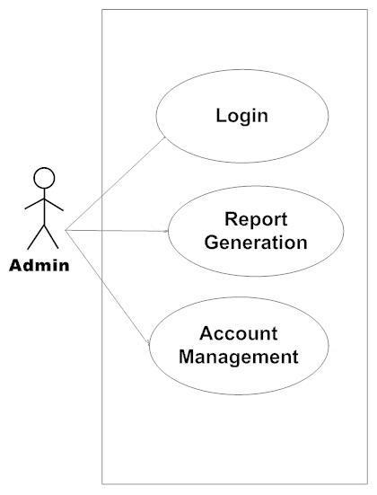

*Fig. Use case diagram for admin*

1. In Admin use case diagram Admin is the Actor.
2. Admin can handle following use cases:
3. Login
4. Report Generation
5. Controls account

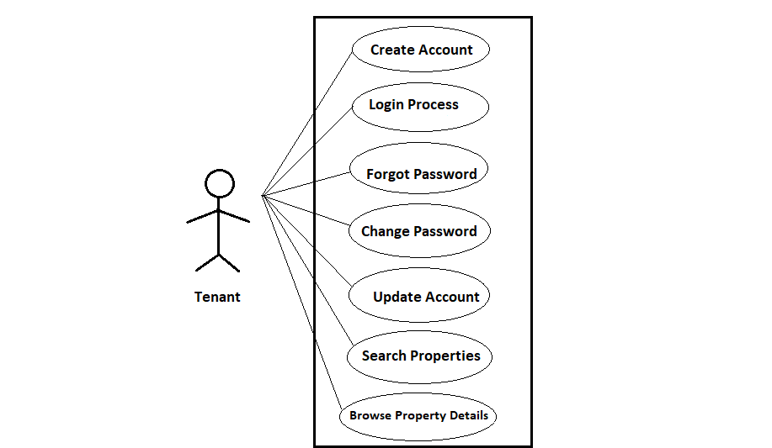

*Fig. Use case diagram for Tenant*

**Tenant:**

1. In Tenant use case diagram Tenant is the Actor.
2. Tenant can handle following use cases:
3. Register
4. Login
5. Forgot Password
6. Change Password
7. Update Account
8. Search and Select Properties
9. Browse Property Details

**Landlord / Owner:**

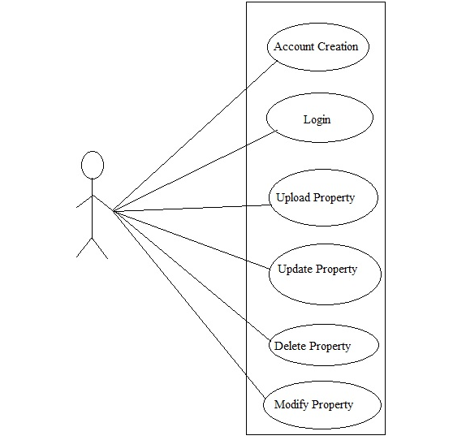

*Fig. Use case diagram for Landlord/Owner*

1. In Landlord/Owner use case diagram Landlord/Owner is the Actor**.**
2. Landlord/Owner can handle following use cases:
3. Register
4. Login
5. Upload Property
6. Update and View Property
7. Delete Property
8. Finalize Property